**Angry Bunnies Changes**

1. I had completed all level without using any extra bunny and power. I had used extras bunny on 17th,18th, and 19th level of pack 3.
2. After completing every 20th level, I didn't get the any Stars.



1. When tapping on the Menu button then user should navigate to the Pack listing page not on the Home Screen.



1. Instruction screen is missing.
2. Pack 4- Level 1 - While zooming out screen is not displayed proper.



1. Need to add level number on the game play screen.
2. Play button and Next level button are same appears. Need to change Play button symbol.

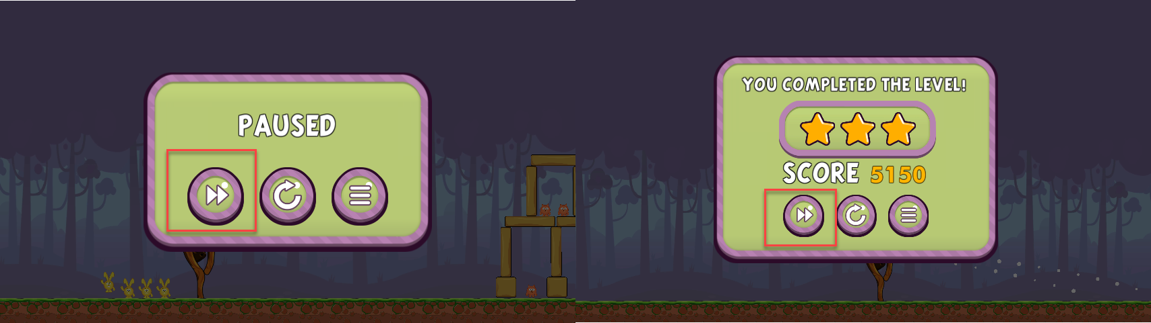

1. Need to set Level Number on the Complete level popup window.

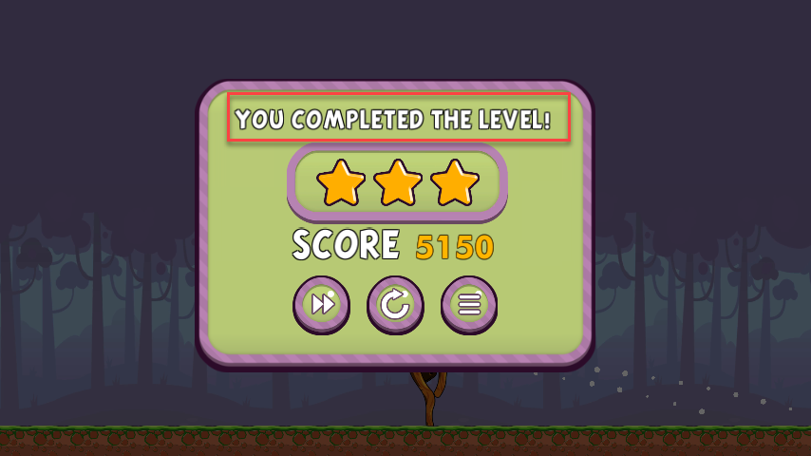

1. This is same as Pack 1 photo…need to be different 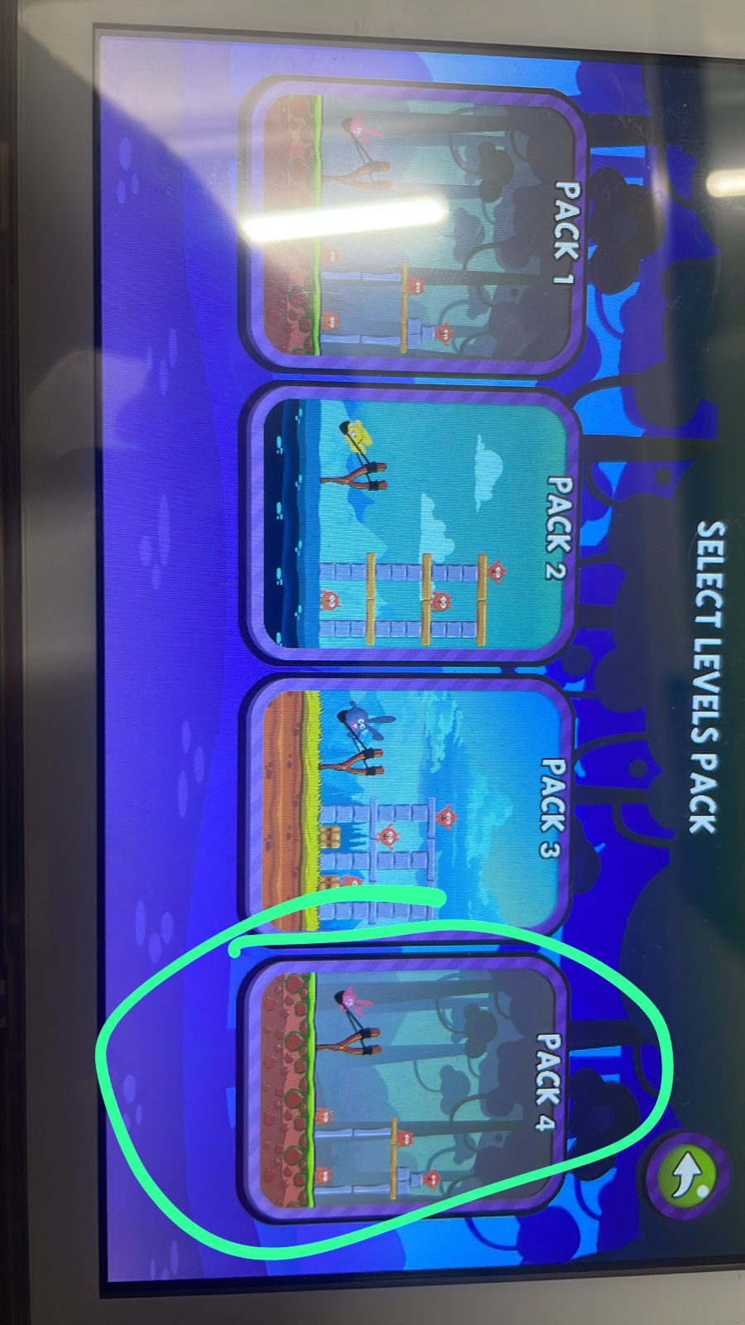
2. New levels visual not ok 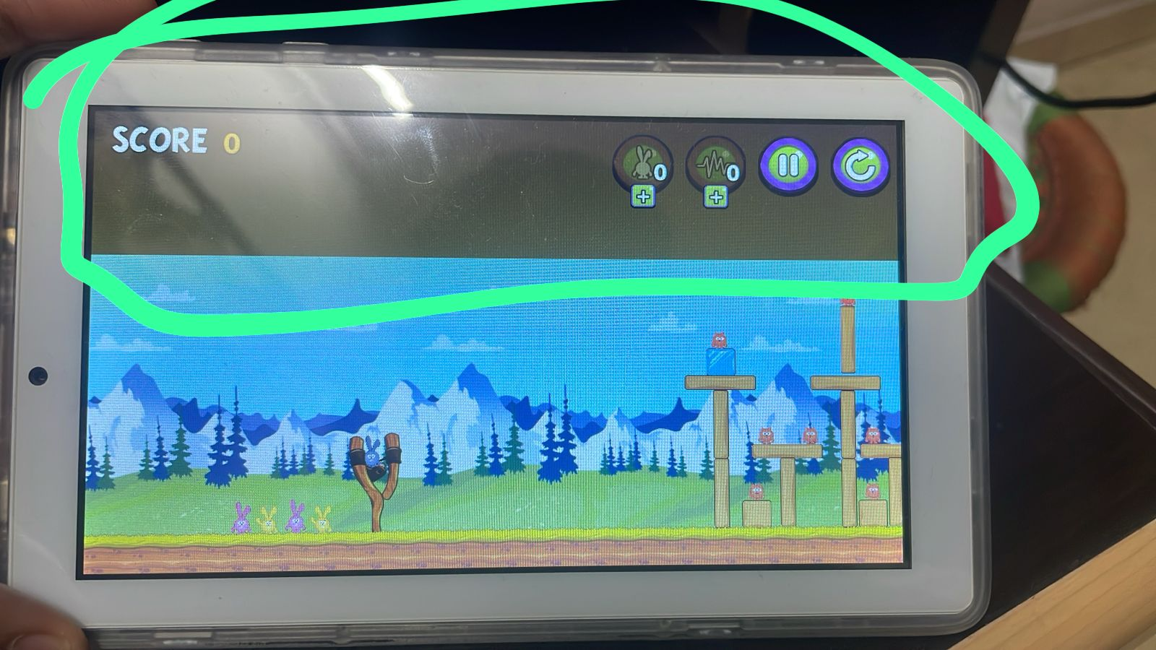
3. There is no music / sound in the game. Need to add that with sound on/off button.
4. There needs to be basic instructions page in main menu. (all textual works). Example –
   1. The objective of the game is very simple.
   2. You are given a select number of bunnies that you must use in the order they are lined up behind the slingshot. You have a limited number of bunnies you can use in each level.
   3. When you start a level, one of your bunnies will be placed in the slingshot. Tap the bunny in the slingshot and pull back to aim. The further back you pull the slingshot determines how far the bunny flies and how fast. Dragging the bunny up or down will determine how high or low the bunny flies. You will see a dotted line in front of the slingshot which indicates the bunnies trajectory.
   4. Lift your finger off from the screen to launch the bunny. This sends the bunny flying. The bunny will destroy or damage any obstacles it runs into.
   5. Tap the screen while in flight to use your bunny's special abilities. Different color bunnies have different abilities. Tap the screen while the bunny is in mid-flight to activate their abilities. You cannot use a bunny's ability after it has hit an object.
   6. In-game you will get instructions on the abilities of different bunnies.
   7. There are various packs to choose from and each pack has multiple levels to play.
   8. You will need to clear previous levels to advance to the next level.
   9. You will get stars after clearing each level indicating your performance in each level.
5. After ending the last level, there should be message – “Congratulations, you have completed all levels. You can continue playing the game and achieve 3 Stars in all levels.”